ABSTRACT TEMPLATE
Theme: HEIs at the Forefront of Transformative Extension: Advancing Evidence-Based, Inclusive, Sustainable, and Resilient Community Development
Instructions: Complete all sections. Select only one paper category and one thematic area. Use clear, evidence-based statements and avoid unsupported outcome or impact claims.

A. Paper Information
1. Title of the Extension Project Paper | LIFT A PAGE, LIFT A MIND: A READING AND NUMERACY ENHANCEMENT PROGRAM FOR GILIGAON ELEMENTARY SCHOOL
2. Author/s and Institutional Affiliation/s Note: Use an asterisk (*) after the name of the project leader. If the presenter is not the project leader, write “paper presenter” after the name | Juram E. Tablate*; Jaymar A. Baculad; Chloe I. Cadiz; Aquilyn D. Campos; Glaisa T. Catalan, PhD; Mary Grace C. Bongabong, PhD & Jeffrey V. Estores  Negros Oriental State University-Siaton Campus
3. Name and Email Address of Corresponding Author | Juram E. Tablate  tablatej@norsu.edu.ph
3. Paper Category | [✓] Completed Extension Project Paper  [ ] Ongoing Extension Project Paper
4. Thematic Area (choose 1 only) | [ ] Food Production, Agriculture, Fisheries, and Natural Resource Systems  [ ] Health, Nutrition, Wellness, and Community Care  [✓] Education, Literacy, Skills Development, and Lifelong Learning  [ ] Livelihood, Entrepreneurship, Cooperatives, MSMEs, and Local Economic Development  [ ] Environment, Climate Action, Disaster Risk Reduction, and Community Resilience

B. Extended Abstract Narrative
Guide: Write concise paragraphs under each required component.
5. Community or Sectoral Need Addressed
Briefly describe in not more than 150 words the validated community, institutional, or sectoral need addressed by the project.
The project addresses the identified need to strengthen the foundational reading and numeracy skills of learners at Giligaon Elementary School. Preliminary observations and school-based assessment results indicated that some learners experience difficulties in reading comprehension, fluency, basic number skills, and applying mathematical concepts in everyday learning situations. These learning gaps may affect their academic performance, confidence, and ability to cope with grade-level competencies. The need is further reinforced by the importance of providing timely and appropriate interventions to learners who require additional academic support. Through project LPLM, the school and community respond to this need by providing engaging and learner-centered activities that enhance reading and numeracy competencies. The program seeks to support learners’ foundational skills while strengthening collaboration among teachers, learners, parents, and the community in addressing learning gaps.
6. Project Objectives
State the main objective/s of the extension project.
To enhance the reading and numeracy skills of selected learners in Giligaon Elementary School through targeted intervention activities.
- Improve learners' reading fluency, comprehension, and vocabulary skills.
- Strengthen learners' numeracy skills in basic operations and problem-solving.
- Develop learners' confidence and positive attitudes toward reading and mathematics.
- Equip pre-service teachers with practical experience in conducting literacy and numeracy interventions.
- Establish a sustainable partnership between the university and Giligaon Elementary School.

7. Extension Methods, Strategies, or Activities Implemented
Describe in not more than 300 words the major extension approaches, methods, strategies, or activities implemented.
The “Lift a Page, Lift a Mind” program utilized a learner-centered and needs-based extension approach to address identified gaps in reading and numeracy among learners of Giligaon Elementary School. The program was implemented through collaboration among teachers, learners, parents, and community stakeholders to ensure sustained academic support.
The program began with the identification of learners who needed additional assistance through teacher feedbacks and their Phil-IRI results. Based on the identified needs, appropriate reading and numeracy enhancement activities were prepared and implemented.
For reading development, learners participated in guided reading, vocabulary-building activities, reading comprehension exercises, storytelling, and individual or small-group reading sessions. Activities were designed to improve reading fluency, comprehension, vocabulary, and confidence.
For numeracy development, learners engaged in basic computation exercises, number recognition, mental mathematics, problem-solving activities, and contextualized mathematical tasks. Games and interactive activities were incorporated to make learning more engaging and less intimidating.
The program also employed differentiated instruction, allowing activities to be adjusted according to learners’ ability levels and specific learning needs. Regular monitoring and formative assessment were conducted to track learner progress and identify areas requiring further intervention.
To strengthen sustainability, teachers and parents were encouraged to reinforce reading and numeracy practices beyond the intervention sessions. The program likewise promoted a supportive learning environment where learners were encouraged to participate actively, practice independently, and develop positive attitudes toward reading and mathematics. Through these integrated strategies, the program aimed to provide accessible, practical, and sustainable support for improving learners’ foundational competencies.
8. Key Outputs, Emerging Results, and Evidence of Outcomes, Adoption, or Utilization
Briefly present in not more than 300 words the documented outputs and emerging results of the project. Include available evidence of outcomes, adoption, utilization, capability-building, institutional change, or public value, if applicable. Claims must be supported by verifiable evidence.
a. Major Outputs or Emerging Results
The results indicate that the program was effective in improving the foundational literacy and numeracy performance of the participating learners at Giligaon Elementary School. In numeracy, the results indicate substantial improvement across all targeted numeracy competencies. Similarly, literacy performance increased and reported a significant improvement.
The findings demonstrate that learners showed marked improvement in both literacy and numeracy after the implementation of the intervention. The increase in post-test performance provides empirical evidence of the program’s contribution to enhancing learners’ targeted foundational skills.
b. Evidence of Outcomes, Adoption, or Utilization
[Type response here. If not yet available, write: “Not yet available.”]
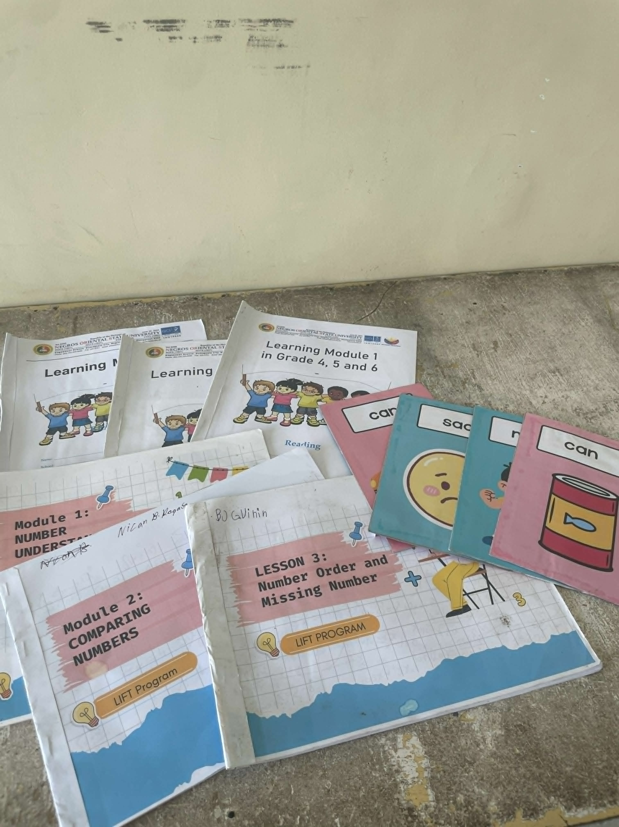
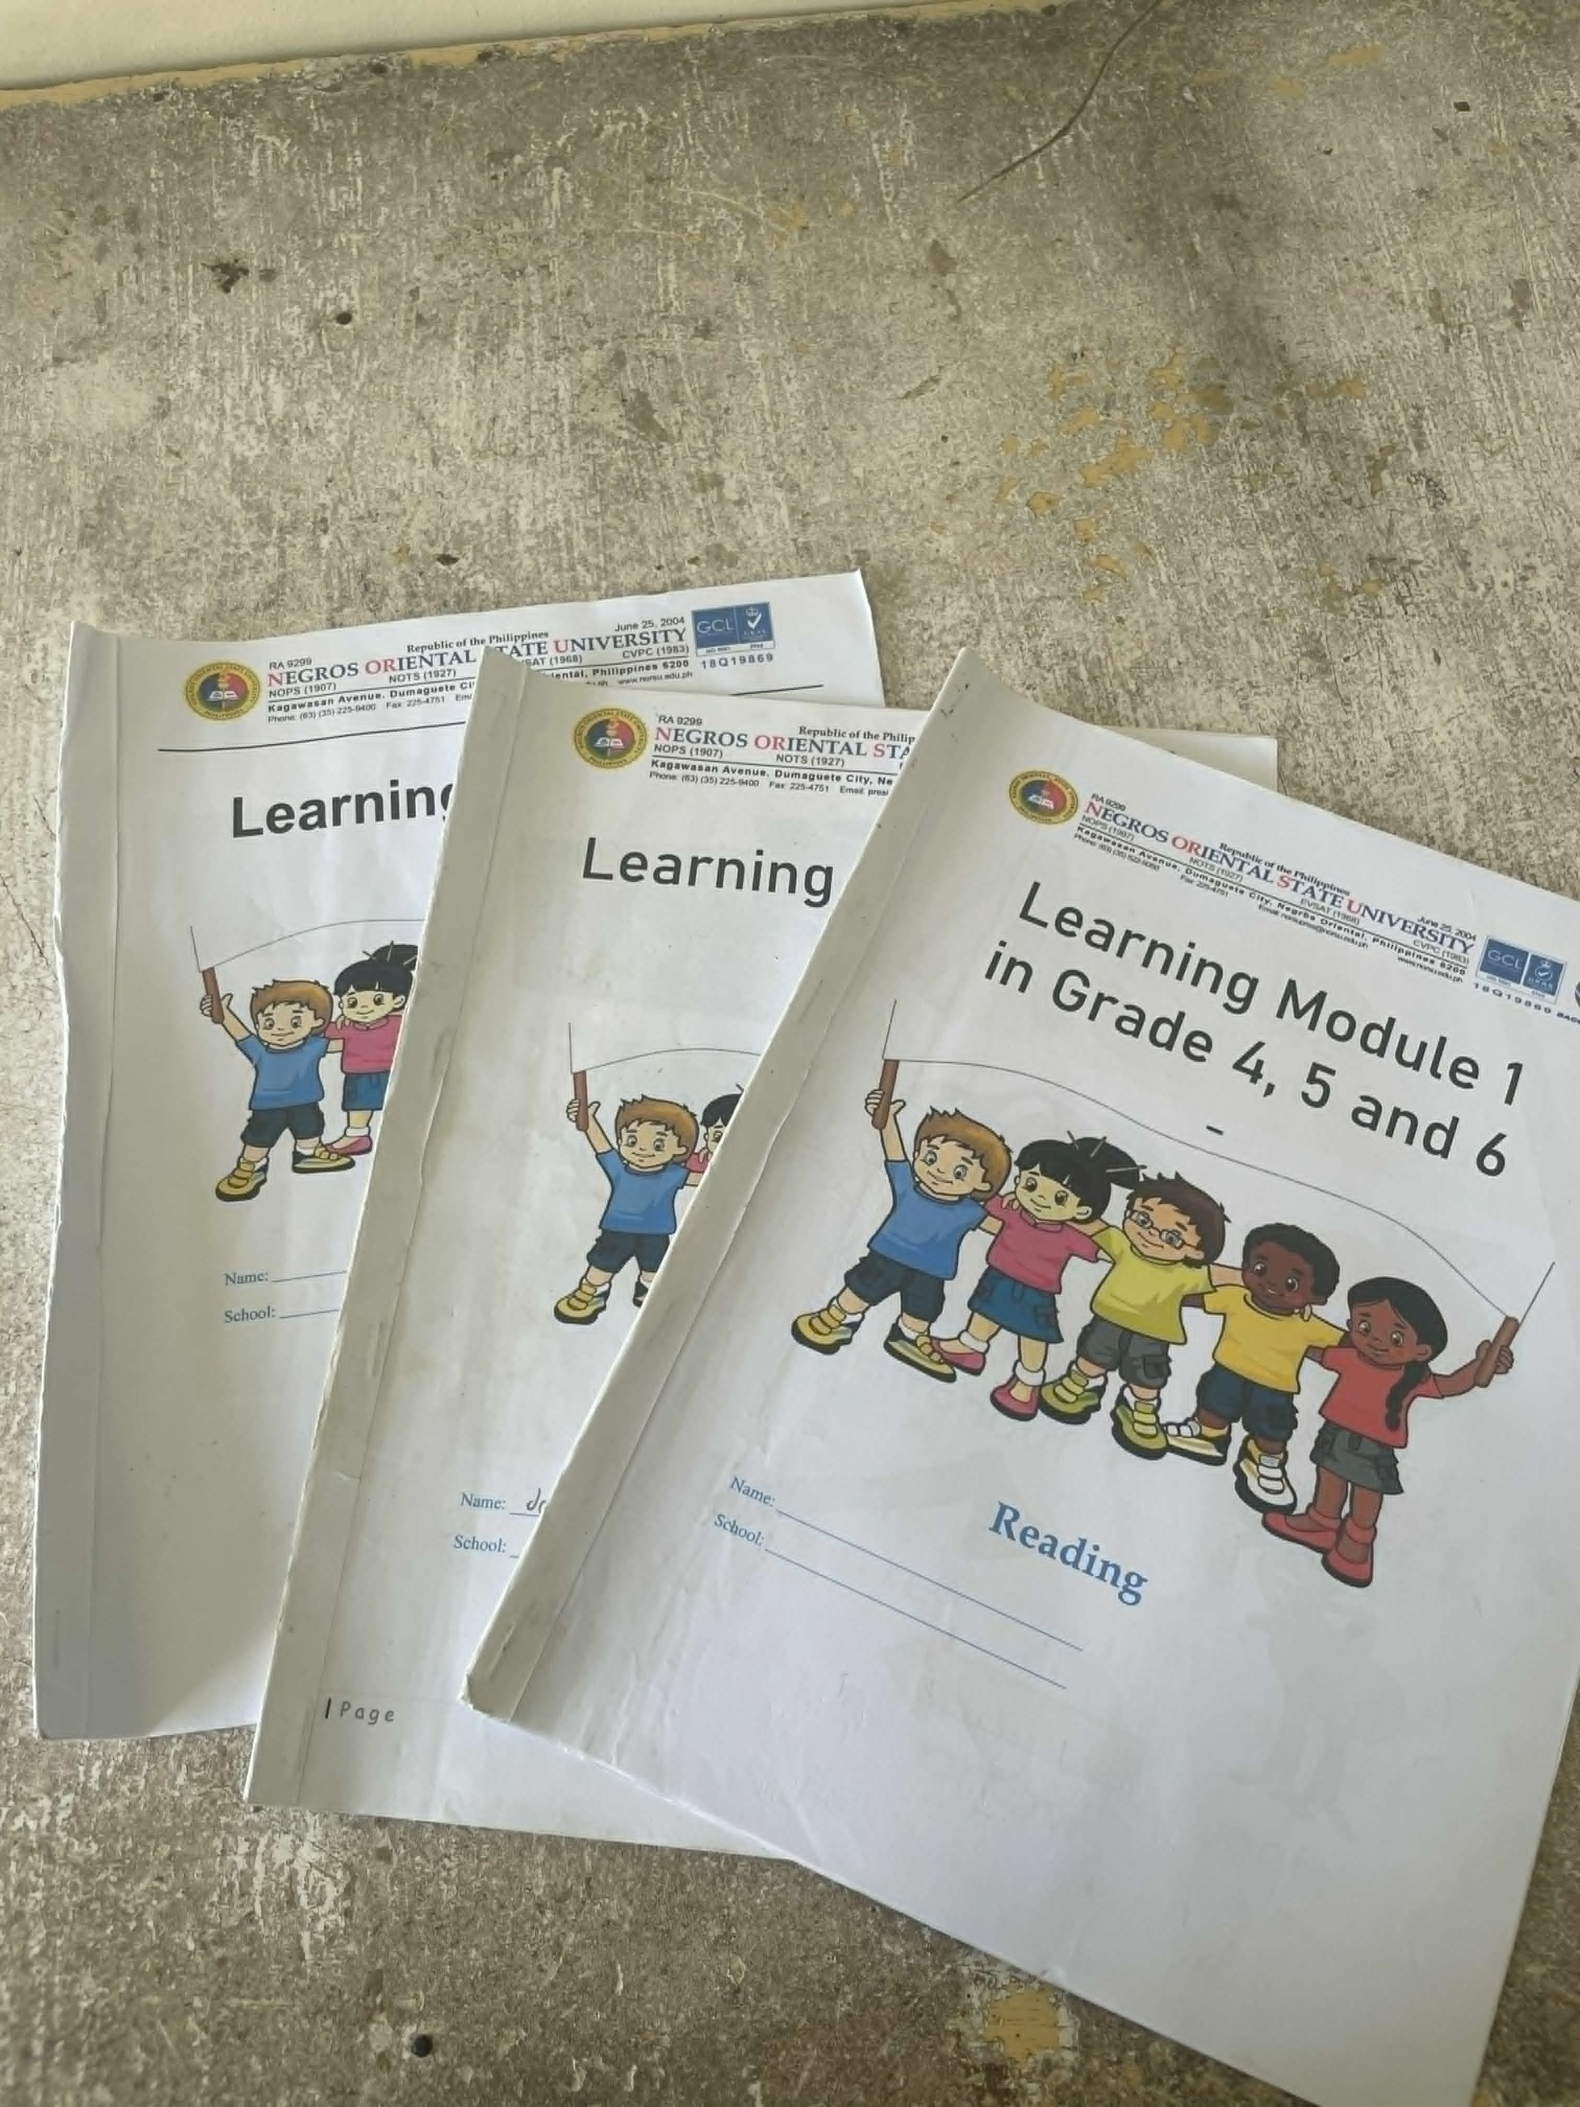

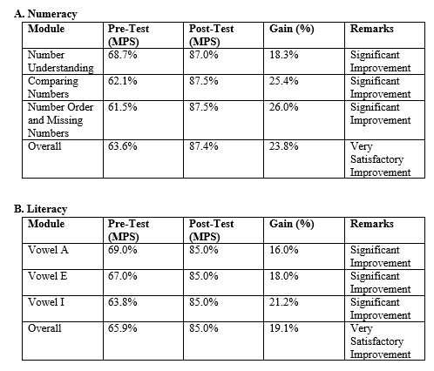

c. Supporting Documents/Evidence Available
[Examples: attendance sheets, monitoring reports, photos, testimonials, adoption records, partnership agreements, policy issuances, utilization reports, or other proof.]
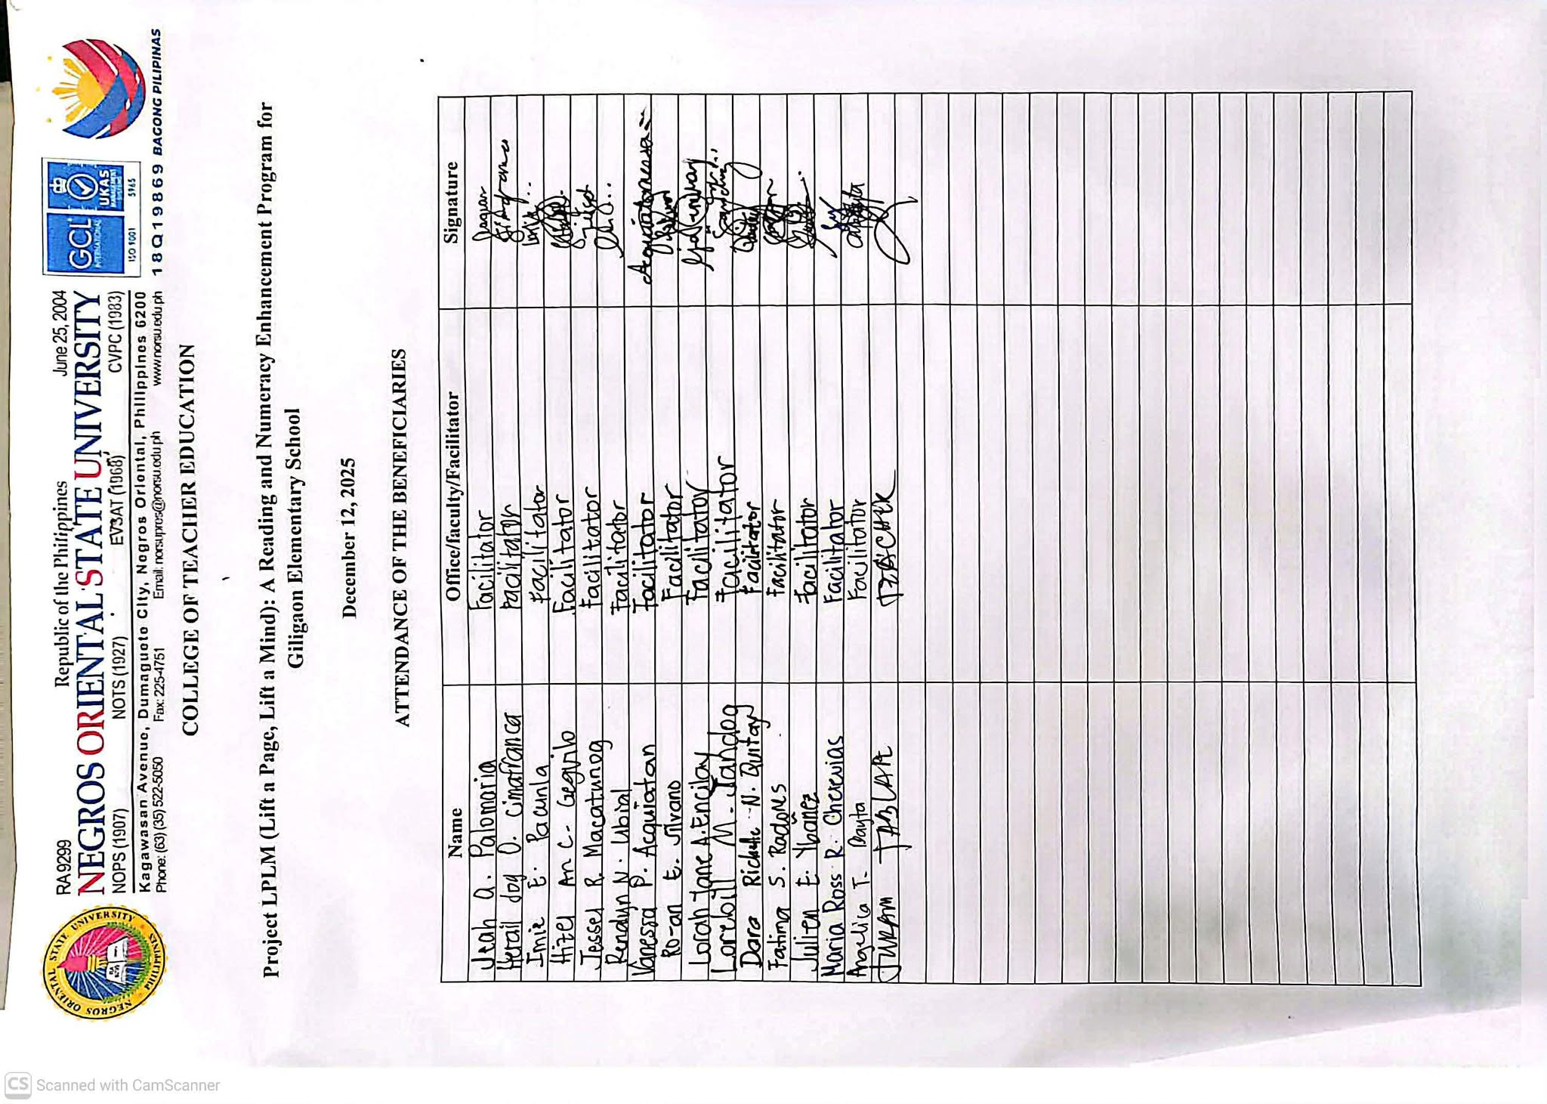
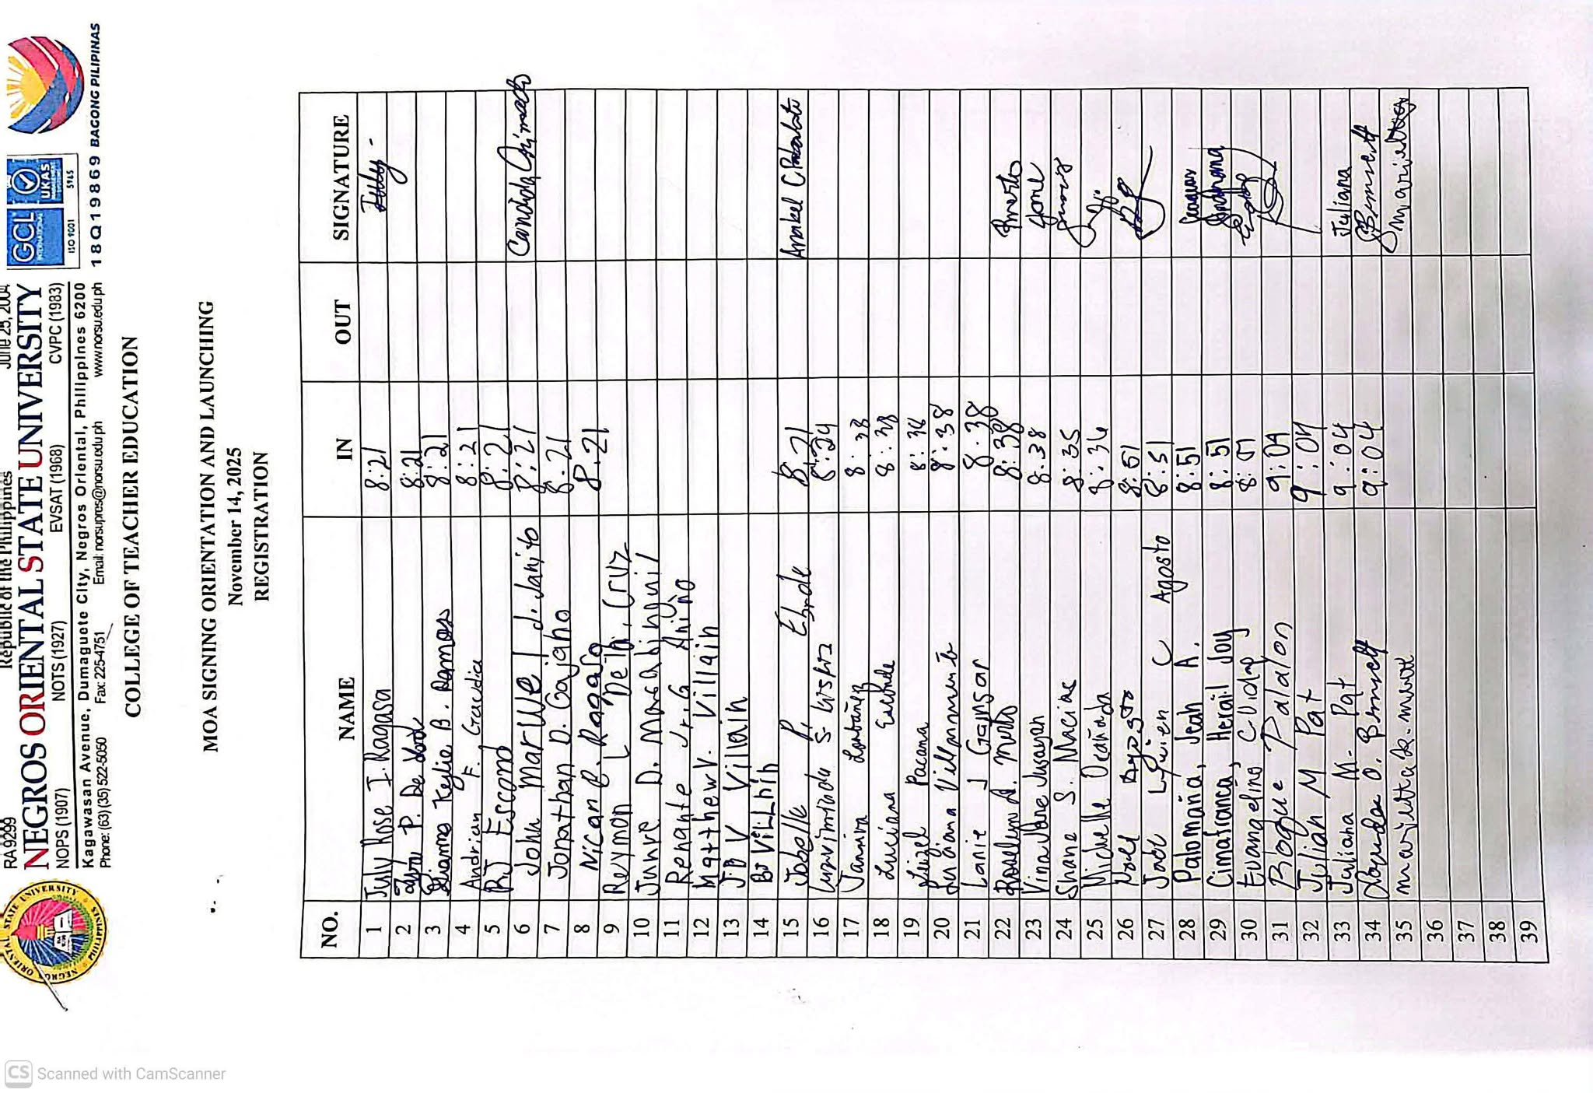
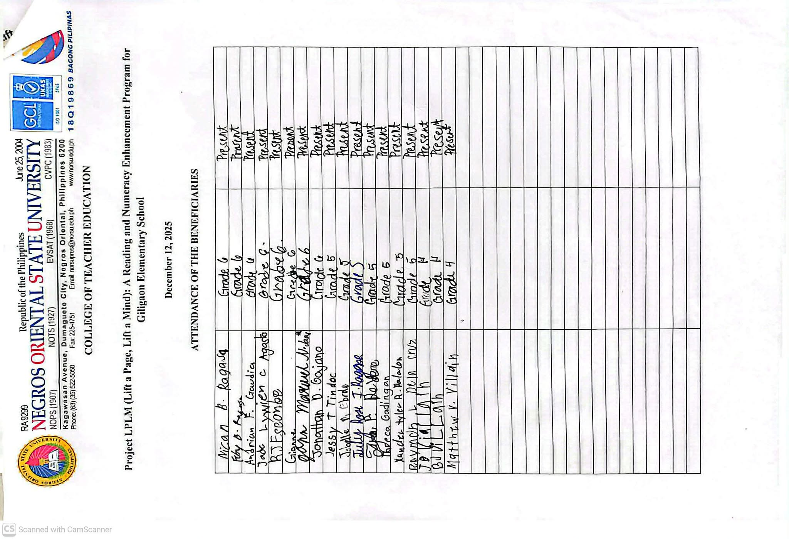

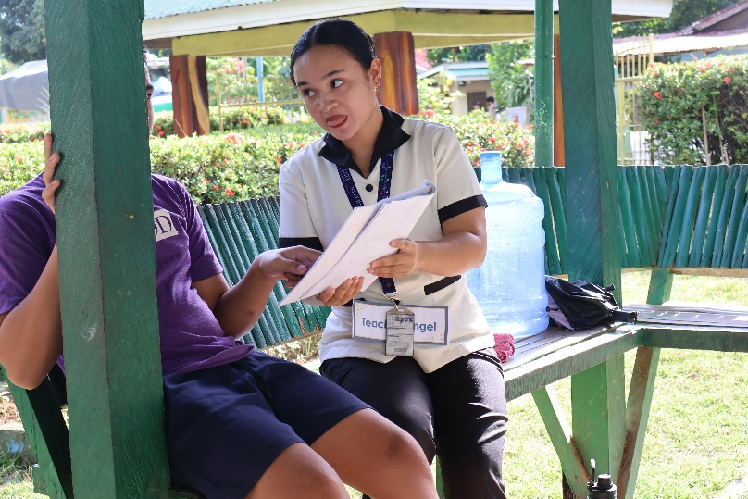
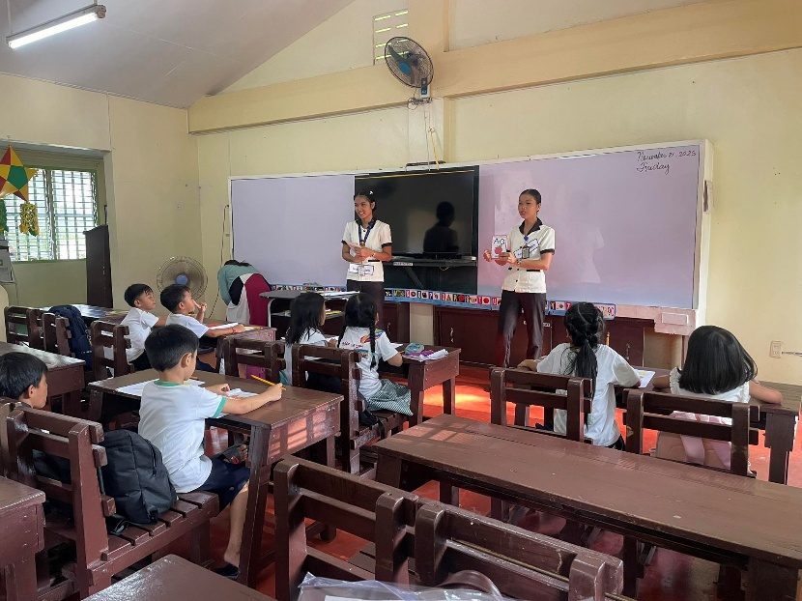
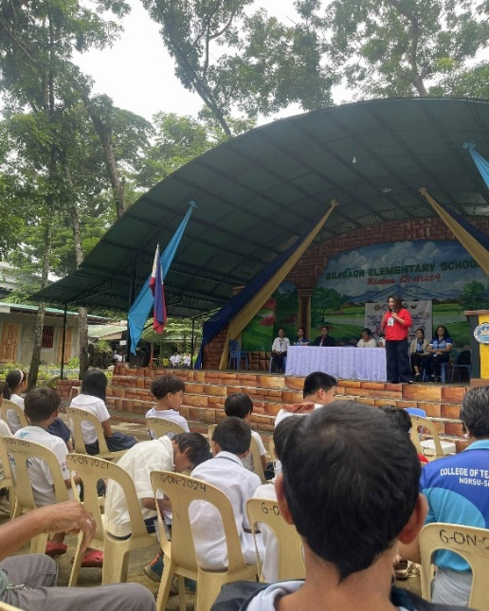
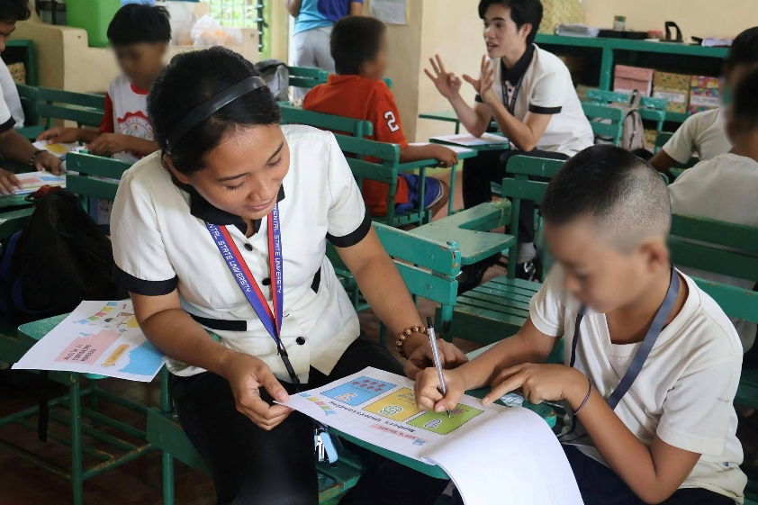
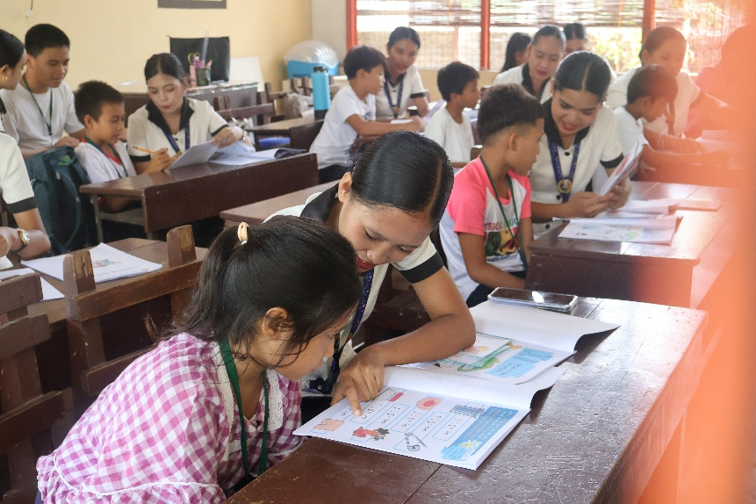

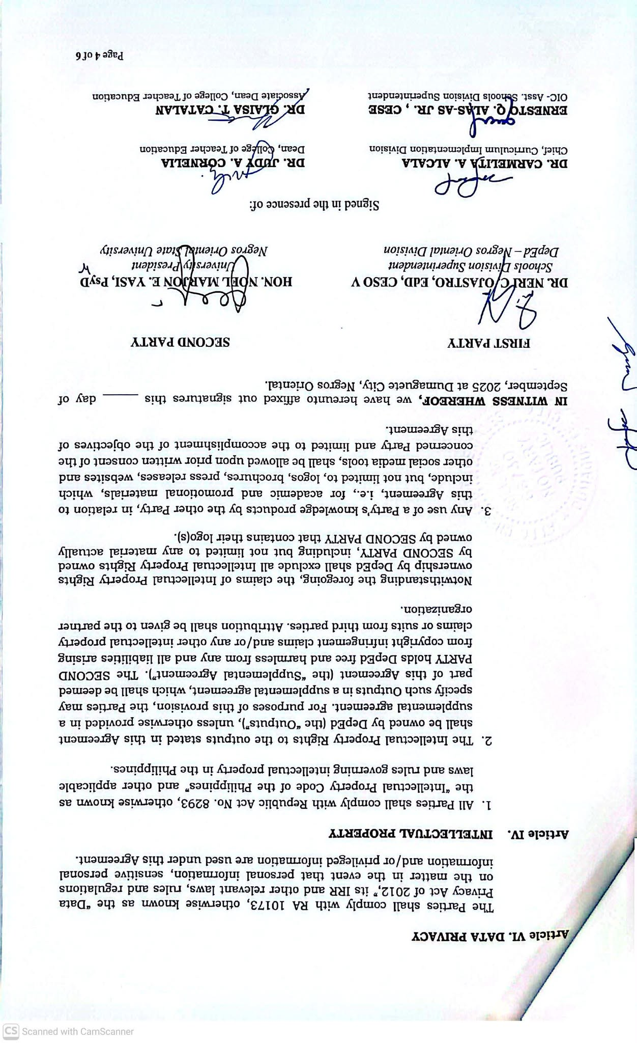
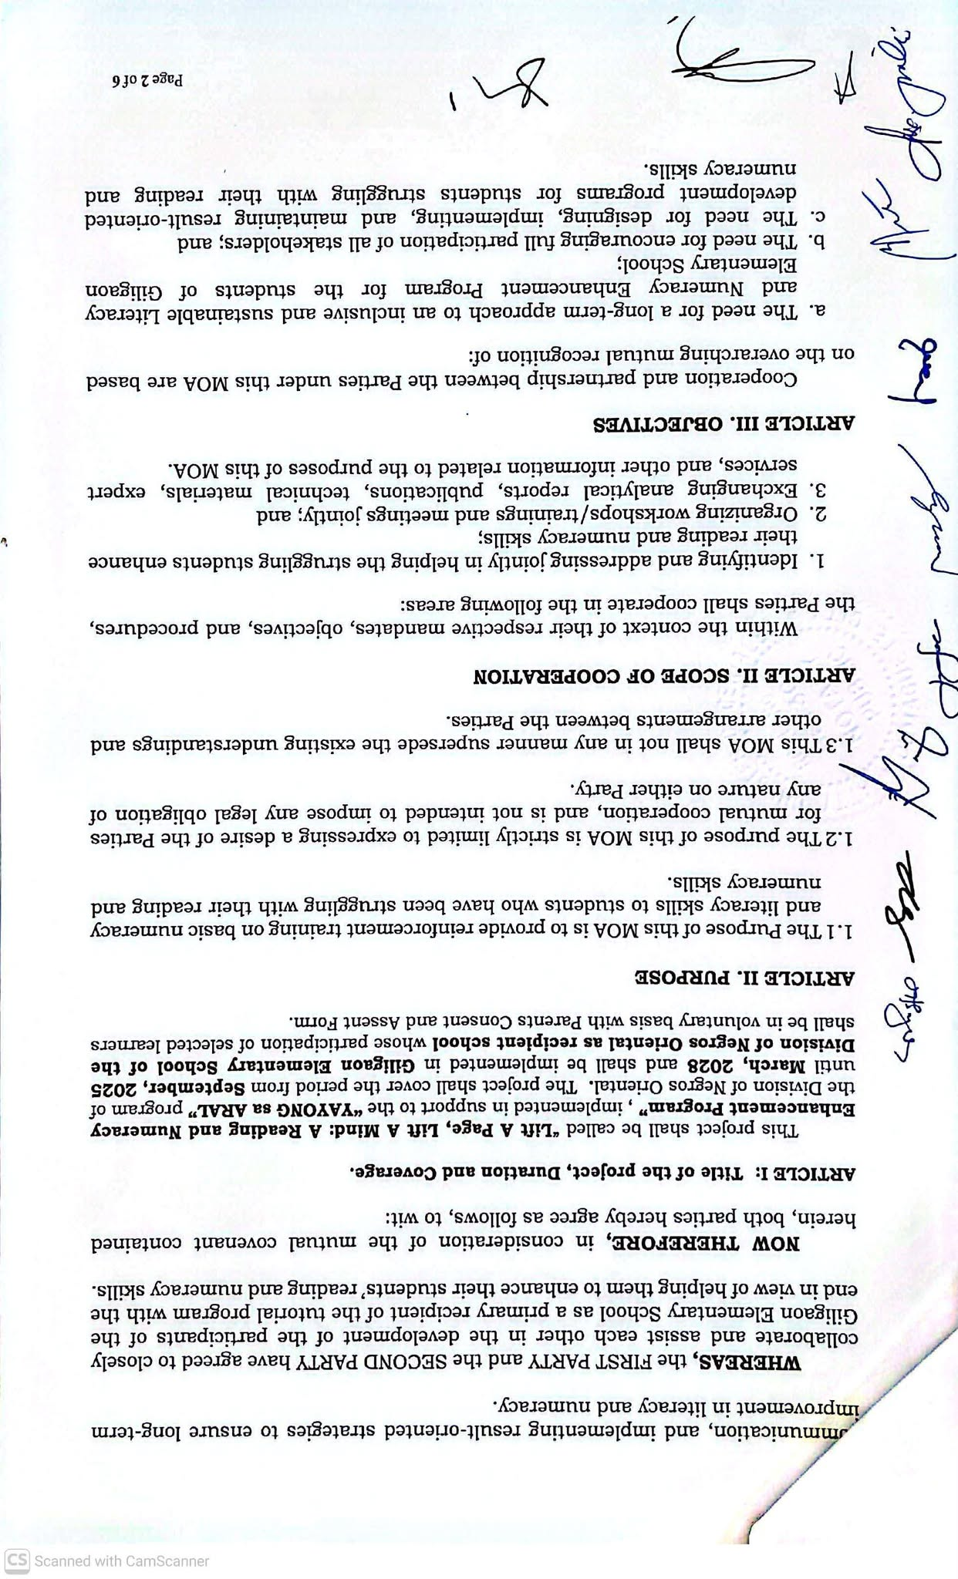
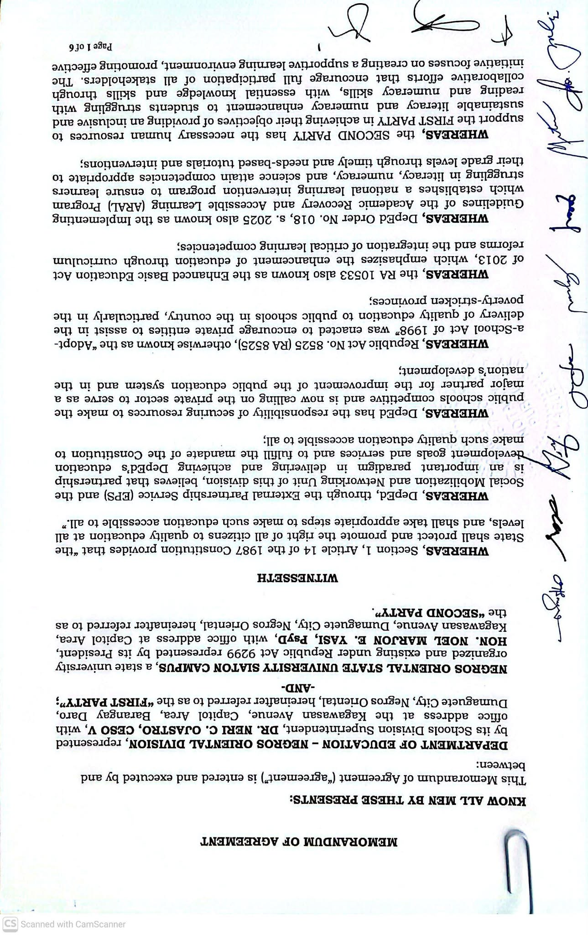

9. Sustainability Direction or Next Steps
Explain in not more than 150 words how the project will be sustained, institutionalized, scaled, or improved, or state the next steps for ongoing projects.
To ensure the continuity and long-term impact of the project, it is recommended that the Reading and Numeracy Enhancement Program be institutionalized as a regular extension activity of the Bachelor of Elementary Education Program. Continuous collaboration between the university and Giligaon Elementary School should be maintained through periodic literacy and numeracy intervention sessions. The establishment of a Reading Corner and Numeracy Learning Station within the school is highly encouraged to provide learners with accessible learning materials and opportunities for independent practice. Teachers may also continue implementing reading and numeracy enrichment activities as part of their classroom routines. Additionally, future extension projects may include parental involvement programs that equip parents with strategies to support their children's reading and numeracy development at home. Regular assessment and monitoring of learners' progress should also be conducted to identify areas that require further intervention and support. Finally, partnerships with local government units, alumni associations, and other stakeholders may be strengthened to provide additional resources, instructional materials, and funding support for the sustainability of the program.
C. Keywords
10. Keywords, three to five keywords: [Numeracy, Literacy, & Extension]
For PEMNet Abstract Review Committee Use Only:
[ ] Recommended for Acceptance
[ ] Not Recommended for Acceptance

Reviewed by: ___________________________________________________
Chair, PEMNet Scientific / Abstract Review Committee

